[NextWork.org](https://community.nextwork.org/c/i-have-a-question?automatic_login=true)

# Visualize a Relational Database

**Prajit Venkatachalam**

[**https://www.linkedin.com/in/prajit-venkatachalam/**](https://www.linkedin.com/in/prajit-venkatachalam/)

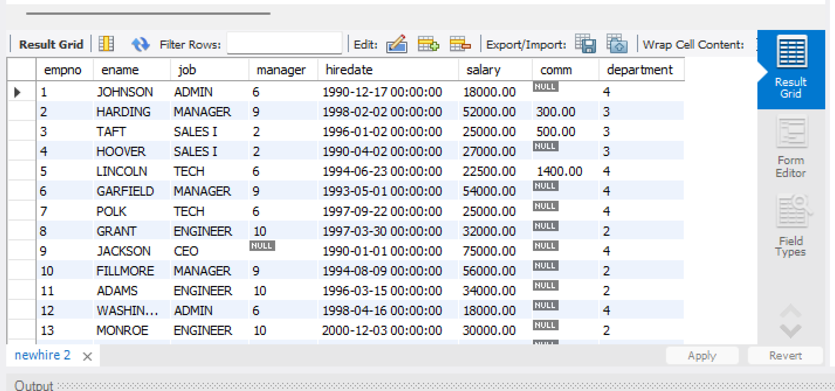



## Introducing Today's Project!

### What is Amazon RDS?

RDS is the Relational Database Service in AWS. It is useful for storing data and creating databases where the data is related to each other.

### How I used Amazon RDS in this project

In today's project, I used RDS to create a relational database, which I populated using MySQL Workbench. I then visualized the data using QuickSight.

### One thing I didn't expect in this project was...

One thing I did not expect in this project was having to use multiple security groups and configure inbound rules to secure the connection for accessing RDS.

### This project took me...

This project took me 2 hours to complete include report writing.



## In the first part of my project...

### Creating a Relational Database

I created my relational database by navigating to RDS in AWS and using the easy create option. I set up the database name and login details during the process.

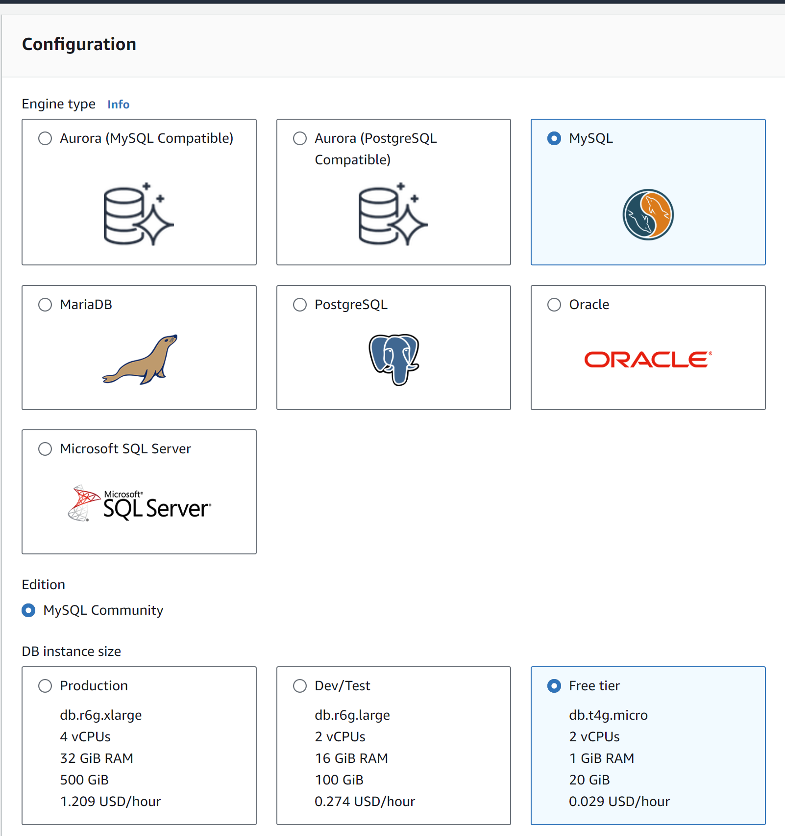



## Understanding Relational Databases

A relational database is a type of database where data is structured in tables that relate to each other. Itʼs like an Excel spreadsheet with rows and columns, where the data in different tables can be connected through relationships.

### MySQL vs SQL

The difference between MySQL and SQL is that SQL is a query language used to extract data from a database, while MySQL is a framework for setting up a relational database. MySQL is widely considered a classic.



## Populating my RDS instance

The first thing I did was make my RDS instance public because I need to connect to it from My SQL Workbench.

I had to update the default security group for my RDS instance because security groups control and manage which traffic can access the AWS resources within them. I added my IP address as an accepted inbound rule.

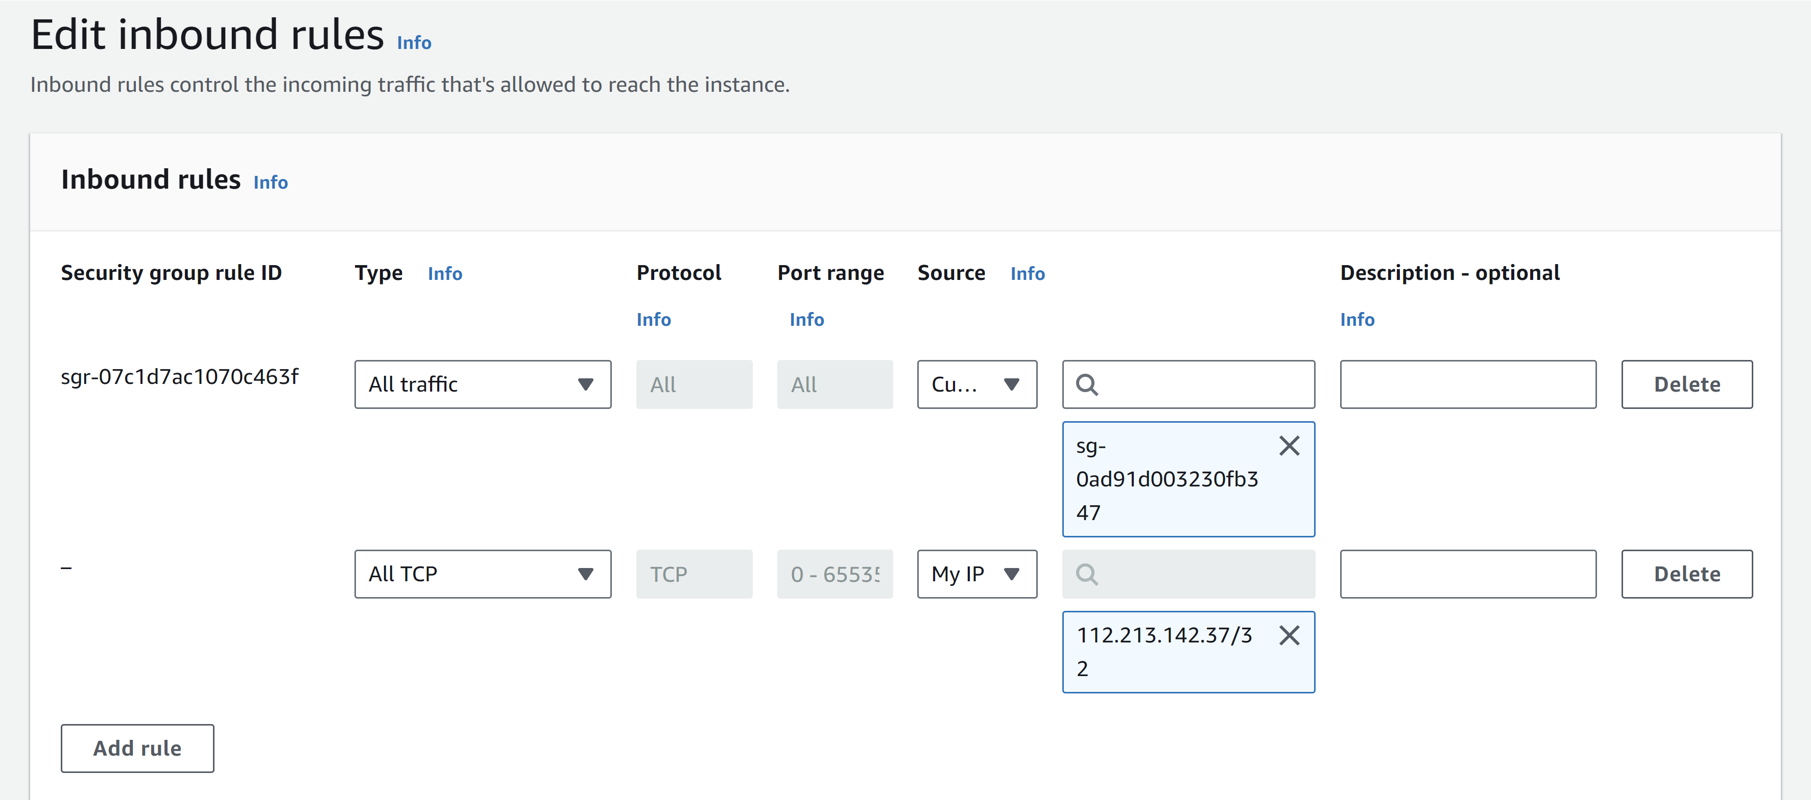



## Using MySQL Workbench

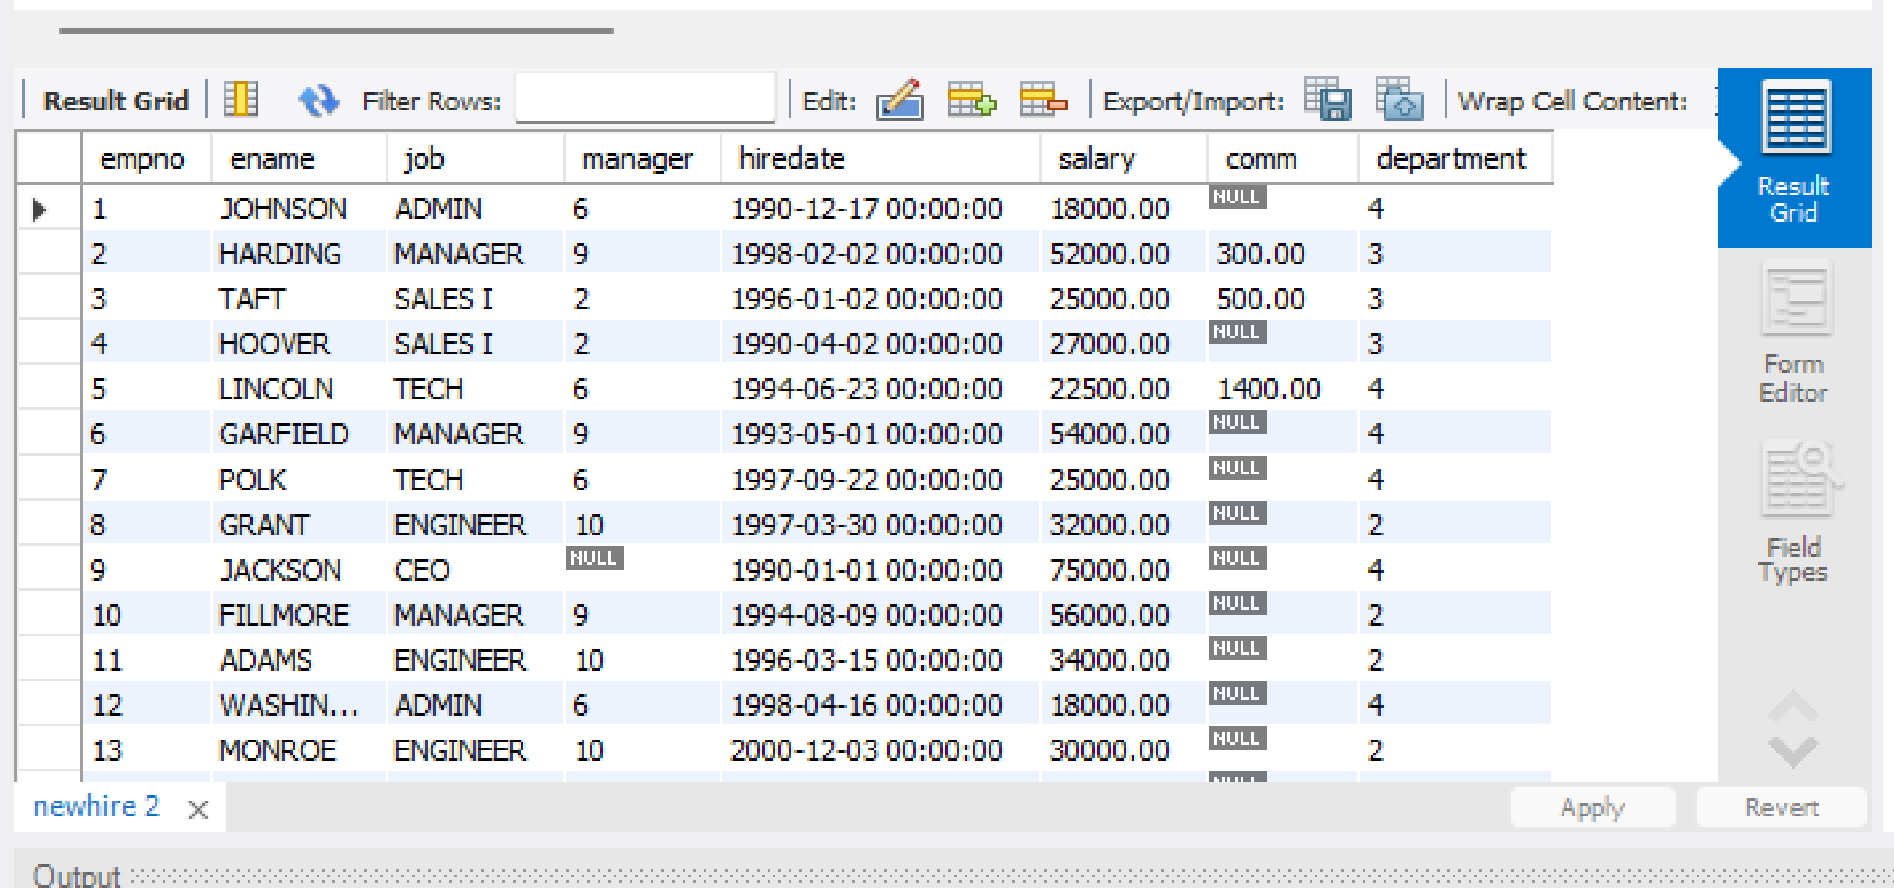

To populate my database, I used SQL in the MySQL Workbench app to create and populate my database tables. First, I connected my MySQL Workbench to my RDS instance using the endpoint, port, username, and password.



## Connecting QuickSight and RDS

To connect my RDS instance to QuickSight, I modified the security group for my RDS instance to allow traffic from any IP address, ensuring QuickSight could connect easily.

This solution is risky because anyone, not just QuickSight, can access my RDS instance. This increases the risk of unauthorized access, especially from potential hackers, making it crucial to keep the data private and secure.

### A better strategy

First, I made a new security group so that my Quicksight will be secured.

Next, I connected my new security group to QuickSight by creating a connection between QuickSight and my VPC, followed by linking it to my security group. I also had to update the IAM role associated with this connection.



## Now to secure my RDS instance

To secure my RDS instance, I made it not publicly accessible and then created a new security group for it.

I ensured that my RDS instance could be accessed from QuickSight by creating the appropriate inbound rules that allowed queries from my QuickSight security group.

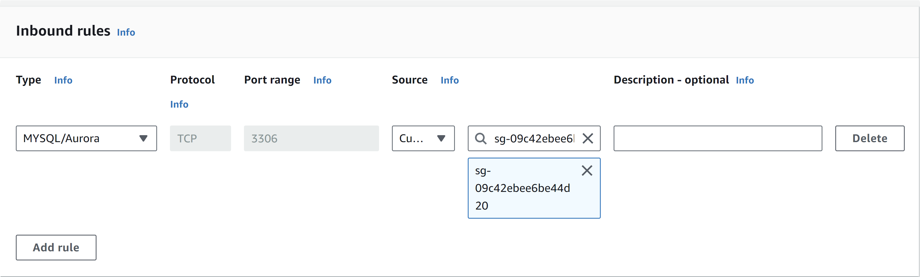



## Adding RDS as a data source for QuickSight

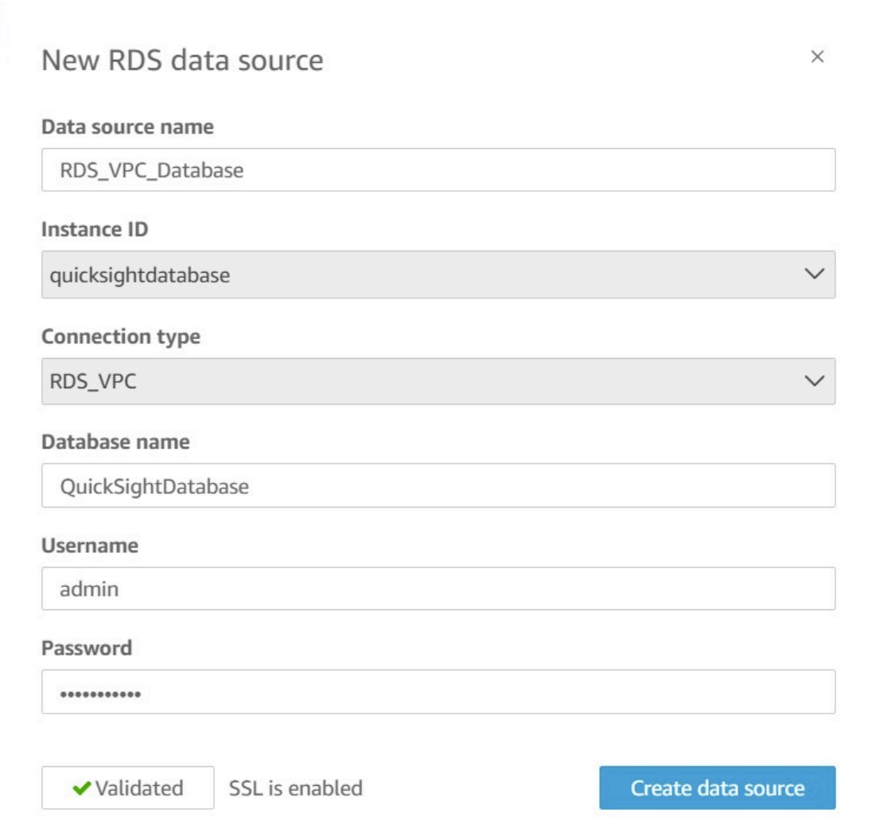

This data source differs from my initial one because it is more secure. I use security groups to access my data in a more secure way, rather than allowing default or public access.

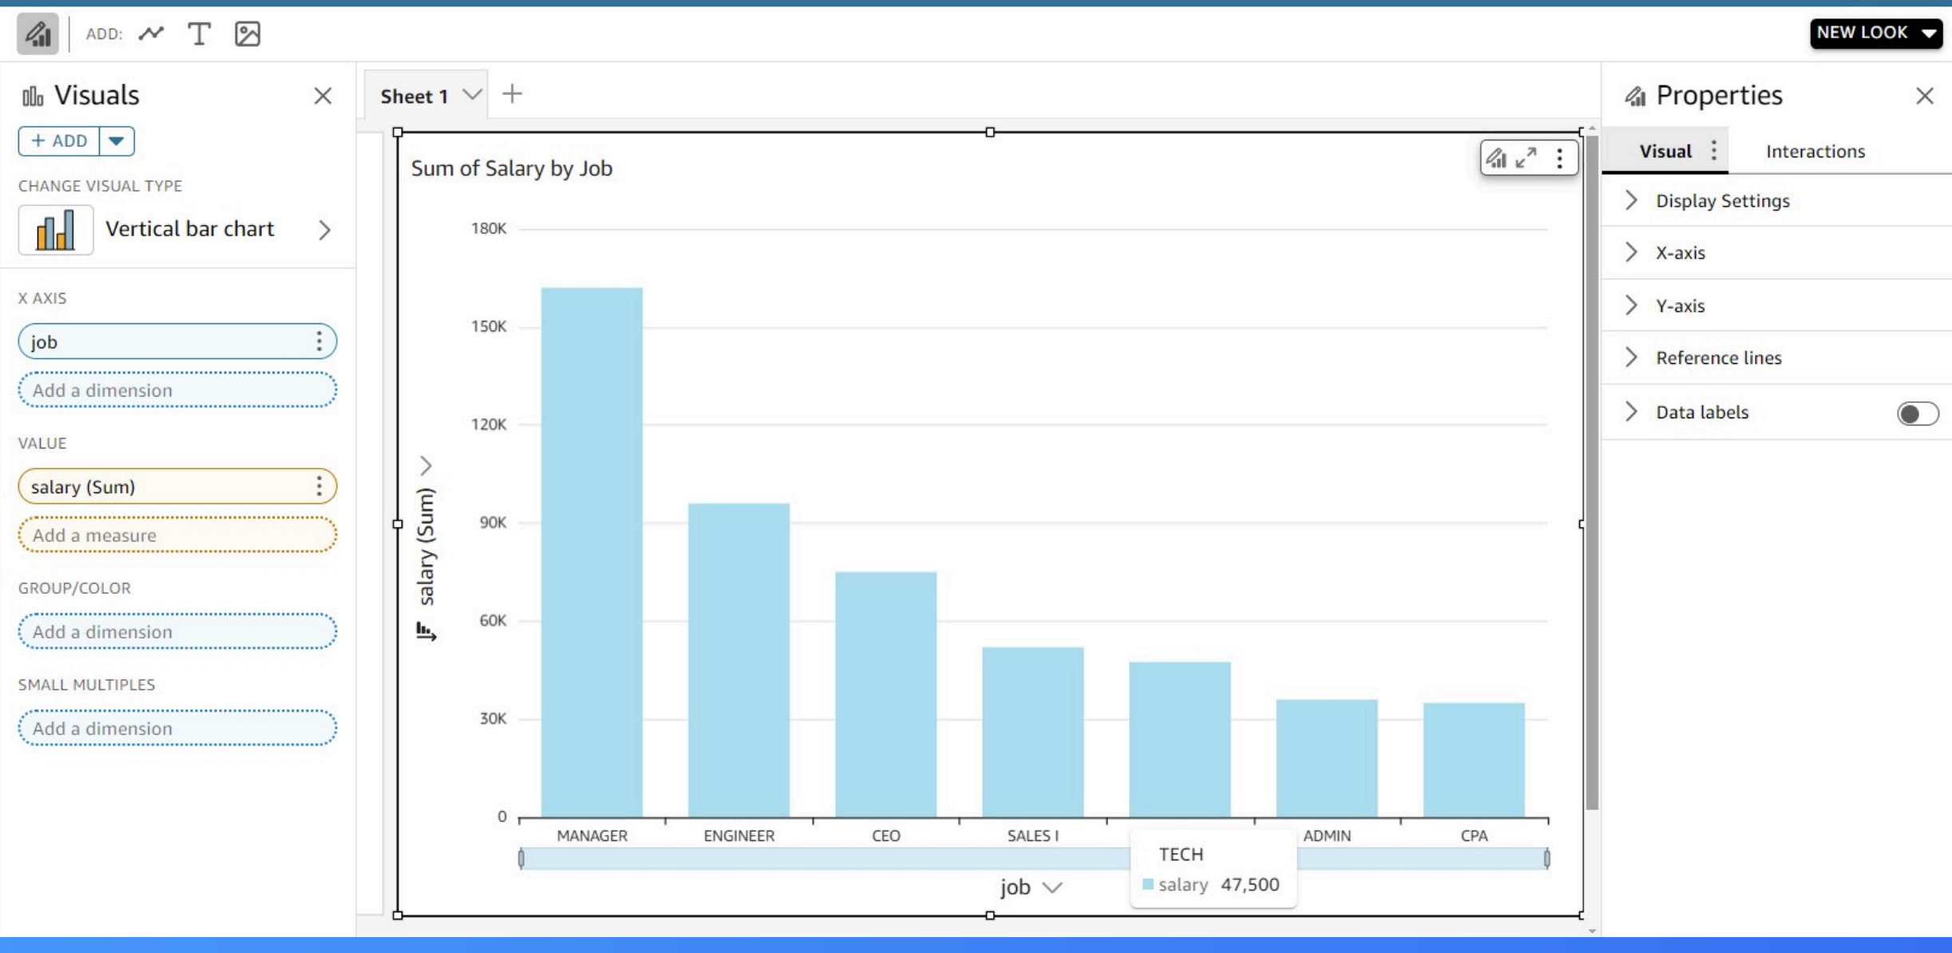

[NextWork.org](https://community.nextwork.org/c/i-have-a-question?automatic_login=true)

# Everyone should be in a job they love.

Check out [nextwork.org](https://community.nextwork.org/c/i-have-a-question?automatic_login=true) for more projects

